8: PO/Requisition Menu: 2. Enter Goods Received

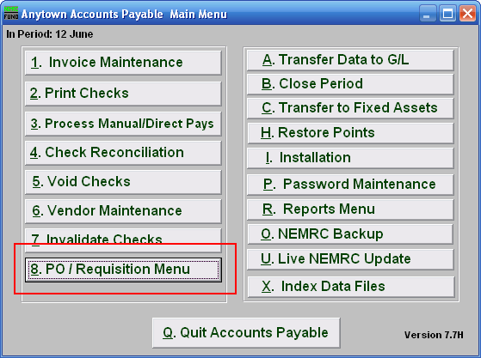
Click on “8. PO/Requisition Menu” from the Main Menu and the following window will appear:

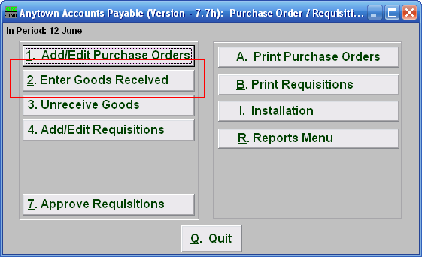
Click on “2. Enter Goods Received” from the PO/Requisition Menu and the following window will appear:
Enter Goods Received

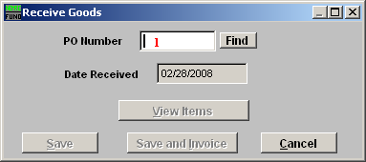
- PO Number: Enter the Purchase Order Number for the goods received.

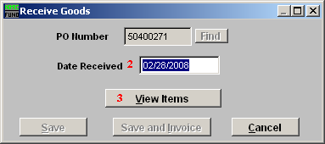
      - Date Received: Enter the Date that the goods were received.

      - View Items: View the items on this Purchase Order Number, the window below will appear:

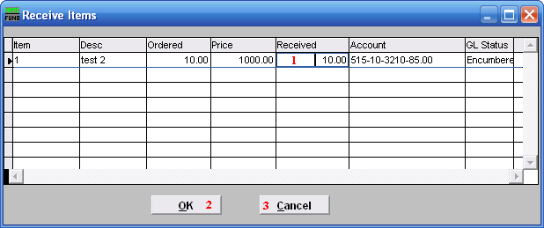
            - Received: This will default to the balance of items ordered. Click to change the amount received.

            - OK: Click this button to move on to the next screen.

            - Cancel: Click “Cancel” to cancel and return to the previous screen.

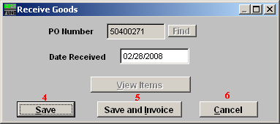
- Save: Click this button to save on this computer. Refer to GENERAL FILE for more information.

- Save and Invoice: Click this button to go directly to Invoice Entry processing for this purchase order. Refer to the document AP M1 INVOICE ENTRY.

- Cancel: Click “Cancel” to cancel and return to the previous screen.

